

**VAPALS-ELCAP**

**Lung Cancer Screening Management Software**

**Technical Journal Article**





**Version 1**

**May 17, 2019**



*OSEHRA Forum Technical Journal Article by*

*the VAPALS-ELCAP Software Development Team*

*is licensed under a*

*Creative Commons Attribution-ShareAlike 4.0 International License.*

*Software is Copyright 2019 Early Diagnosis and Treatment Research Foundation, Vista Expertise Network (VEN), and Paraxial*

The original management system was created and donated by Early Diagnosis and Treatment Research Foundation within the International Early Lung Cancer Action Program (I-ELCAP), an international program of lung cancer screening.

Licensed under the Apache License, Version 2.0 (the "License"); you may not use this file except in compliance with the License. You may obtain a copy of the License at: http://www.apache.org/licenses/LICENSE-2.0. Unless required by applicable law or agreed to in writing, software distributed under the License is distributed on an "AS IS" BASIS, WITHOUT WARRANTIES OR CONDITIONS OF ANY KIND, either express or implied. See the License for the specific language governing permissions and limitations under the License.http://www.apache.org/licenses/LICENSE-2.0http://www.apache.org.

**Table of Contents**

1 Introduction 4

1.1Submission 4

1.2Architecture 4

2 VAPALS-ELCAP Functionality 7

2.1 Forms 7

2.2 Notes and Reports 8

2.3 User Reports 8

3 User Interface 8

4 Executed Unit Tests 13

5 Code Walkthrough 14

5.1Fileman Files 14

5.2Graphs 14

5.3Routine Breakdown 14

5.4Web Templates 15

6 Conclusion 15

Appendix 16

Mumps Routines 16

Unit Test Suite 17

# Introduction

The VAPALS project, which is classified as an Enterprise Wide Initiative by the VA Office of Rural Health, is designed to increase access to early detection lung-cancer-screening programs throughout VA. It requires the installation of a Vista-based patient-management system developed in collaboration with software professionals who have extensive experience supporting VA applications and the I-ELCAP (International Early Lung Cancer Action Plan) team. The I-ELCAP team has been researching early lung cancer detection and treatment for over 20 years.

This project would not be possible without the funding of the Bristol-Myers Squibb Foundation and the VA Office of Rural Health.

## Submission

This is the submission of the VAPALS-ELCAP version 18 software. This software was designated as version 18 since it is closely based on software developed by the I-ELCAP program and used by them for 17 years before the VAPALS program was funded.

This submission includes 78 routines, 33 of which are unit test routines. These routines are provided in a Docker instance. This submission also includes documentation: a technical manual, user manual, and install guide will be included.

## Architecture

This version of the VAPALS-ELCAP software is designed to run on a separate instance of Vista that has been modified to support management of lung-cancer-screening patients. Standard patient information and healthcare functions remain with the VAMC’s Vista system while new lung-screening-relevant patient information and functions are handled by the VAPALS-ELCAP software system. Clinicians will access the system through an option on the tools menu in CPRS or through a web url to a server situated within the VA firewall. These methods of access call up a web-based interface allowing the user to access demographic information pulled from Vista as well as forms, data, and tools specific to lung-cancer screening stored in the VAPALS-ELCAP database. Communication from VAMC’s main Vista instance to the VAPALS-ELCAP system is performed regularly using standard remote procedure calls to maintain consistent patient data across both databases.

This software is written in a combination of Mumps, Json, and HTML to work with web browsers and Vista.

Patient data pulled from Vista or entered into the forms are stored in Graphstores. They are schema-less non-sql storage for structured data, optimized for high performance, flexibility, and accuracy. They represent exactly what the user has entered on the forms without transformation or interpretation. Any required interpretation or transformation is done by the processes that use the graphs. Mumps is ideal for storage and retrieval of these kinds of graphs.

Below is a diagram showing the top-level flow of control through the Mumps routines.

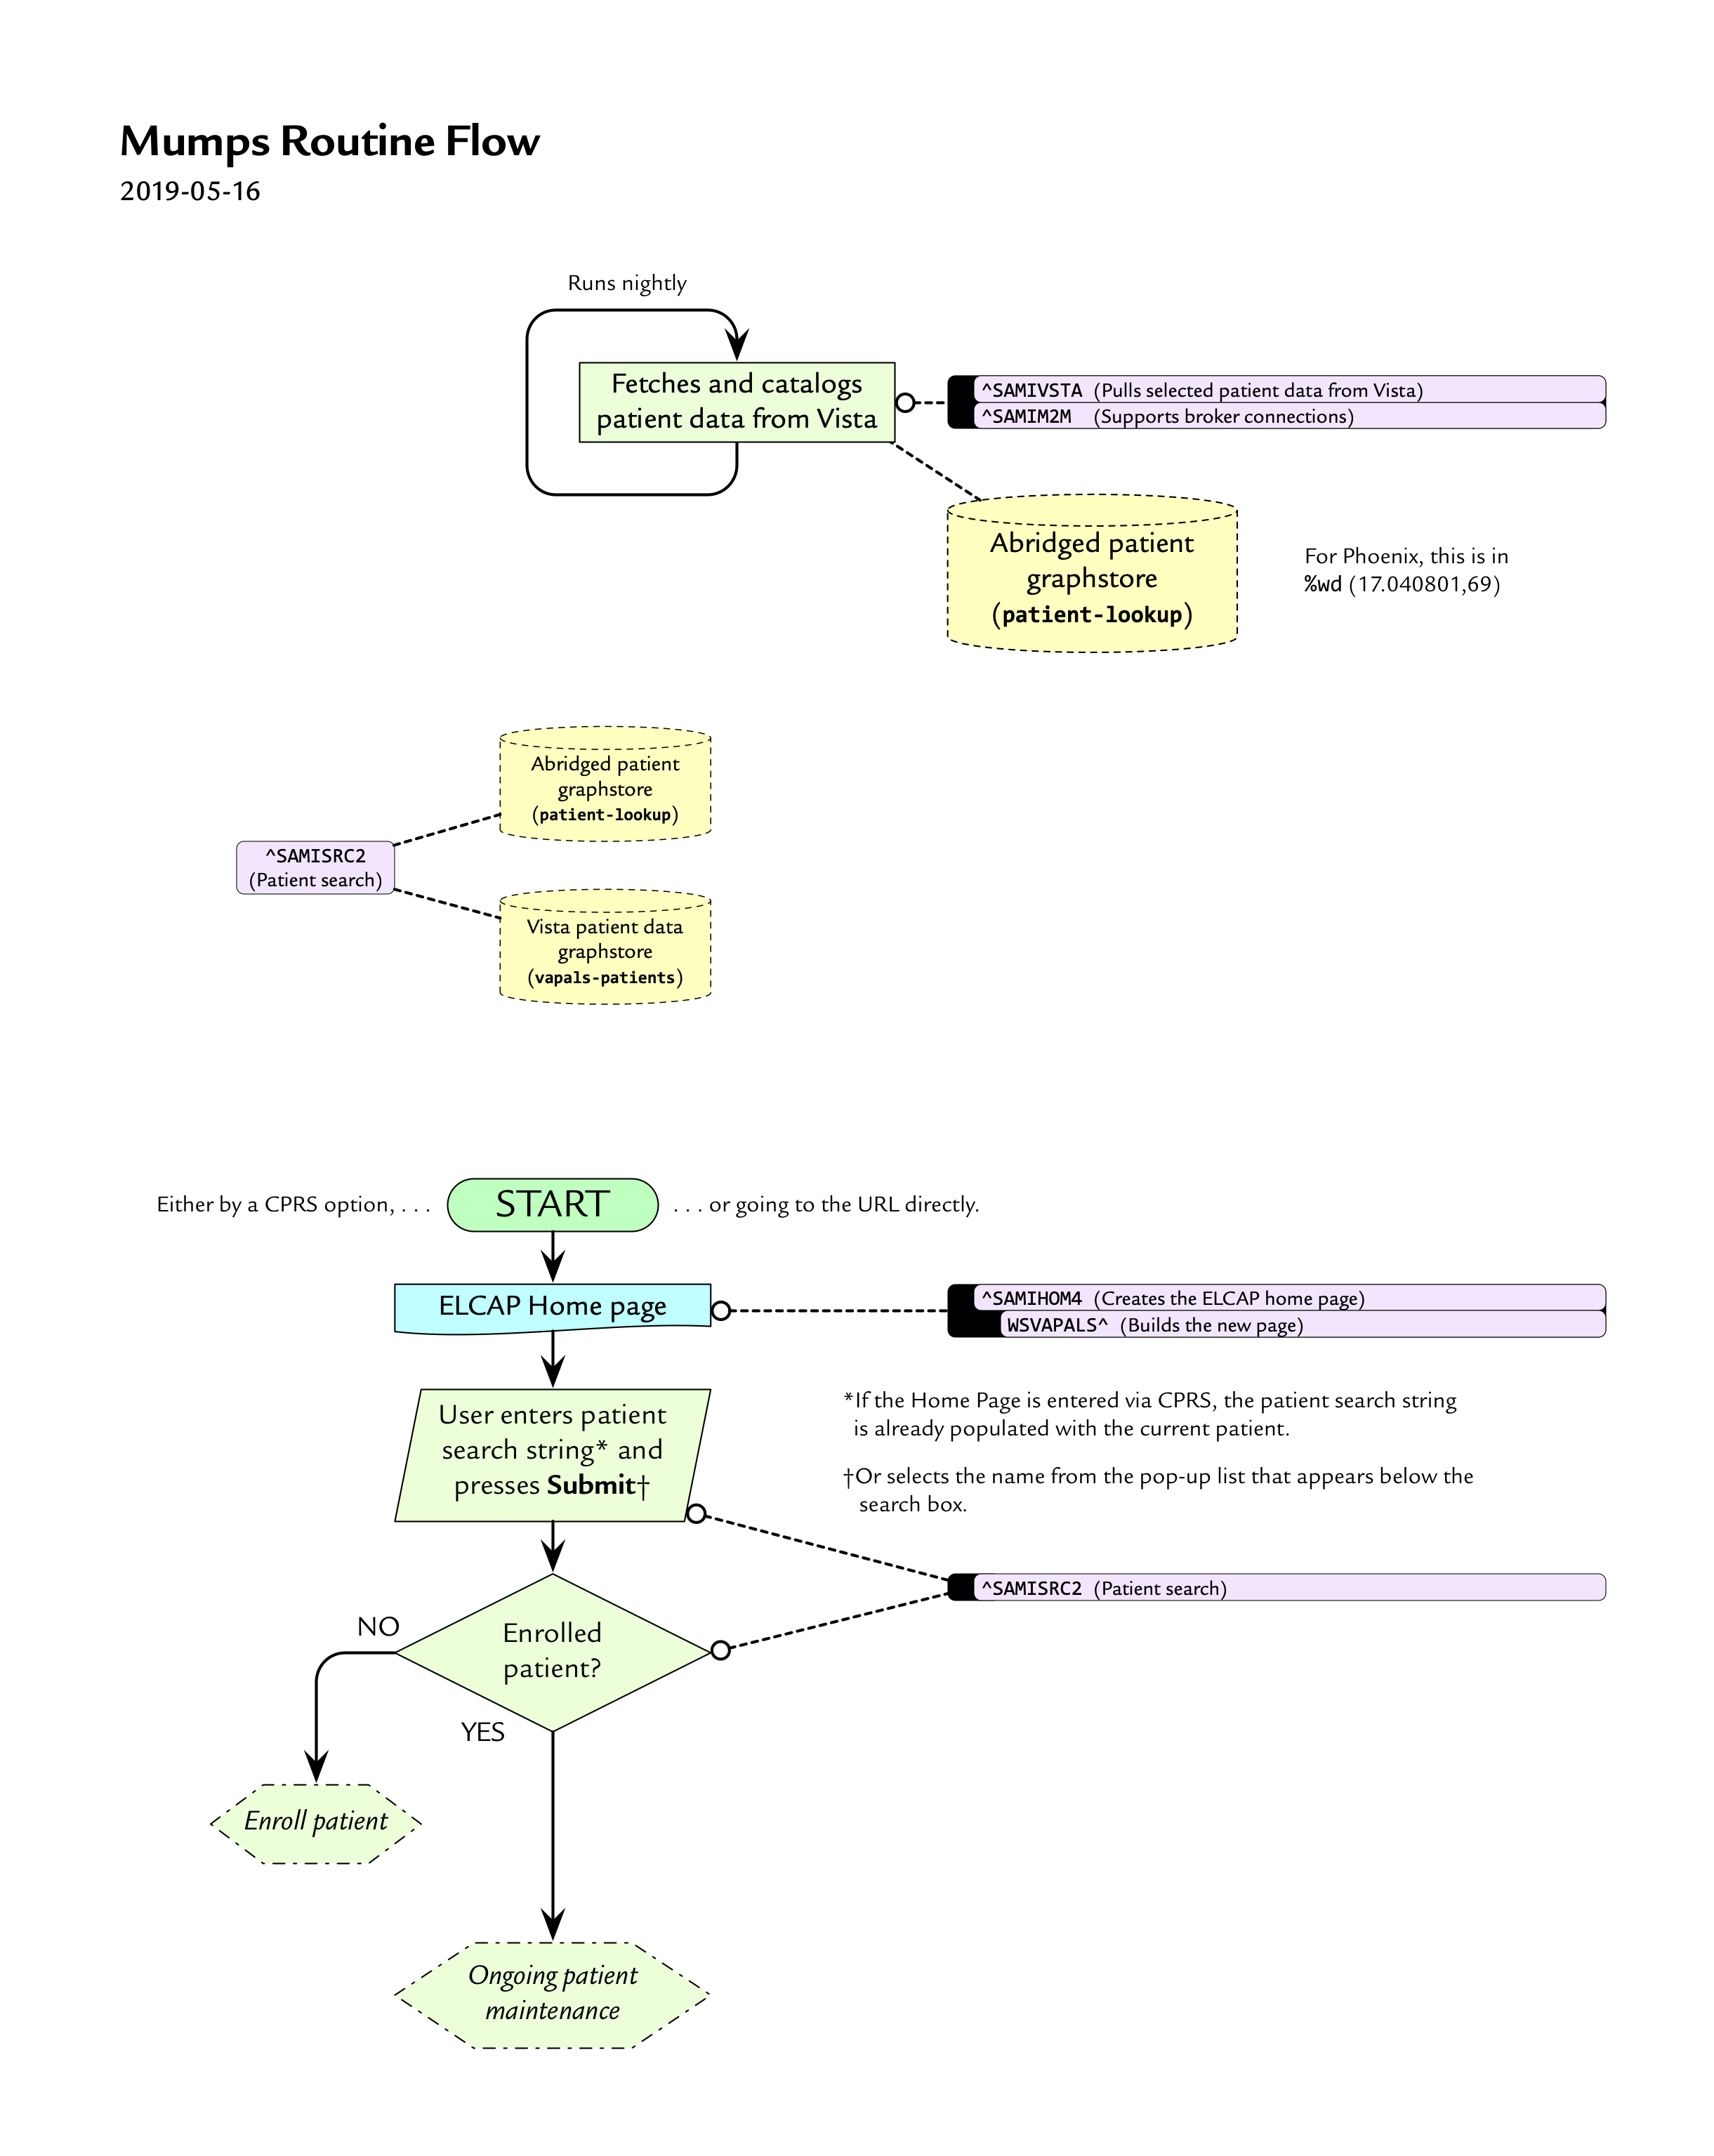

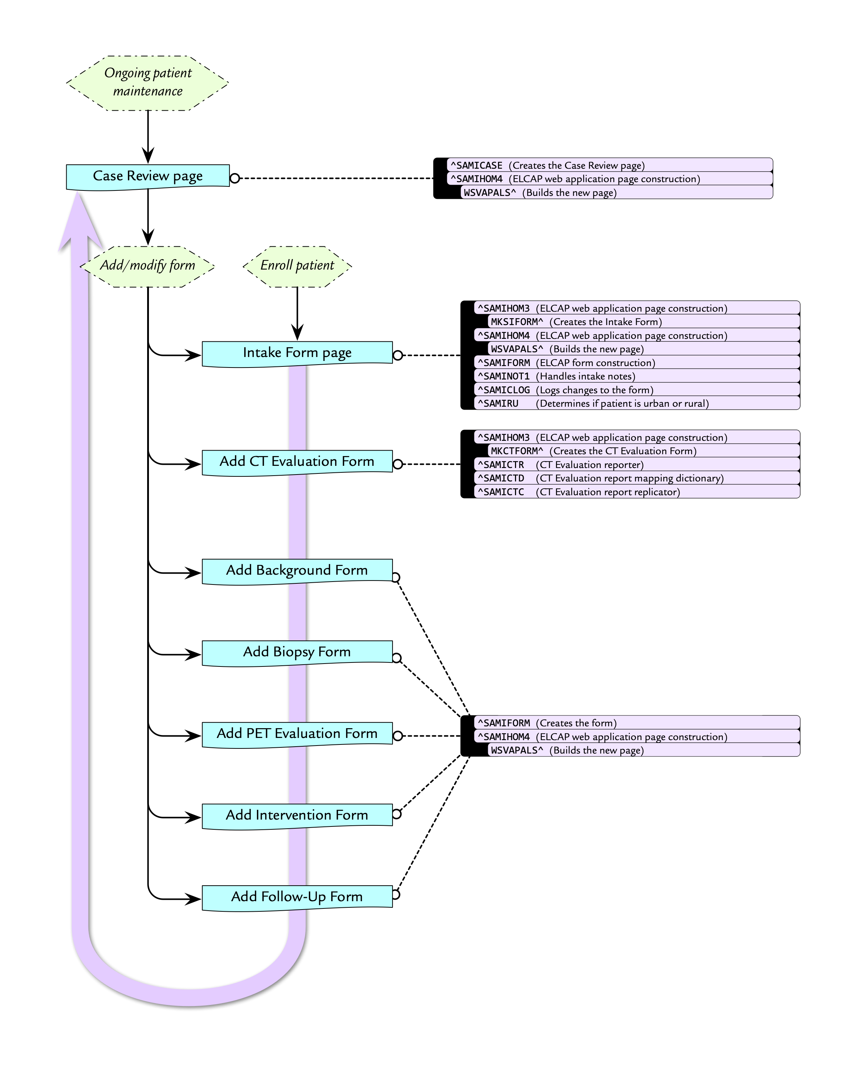

# VAPALS-ELCAP Functionality

The Early Lung Cancer Action Program (ELCAP) has been collecting data related to lung cancer screening and treatment for over 20 years. The ELCAP software program was developed to support ELCAP research and treatment protocols using html, javascript, TCL, and other technologies. During the last 18 years, the software has been constantly updated and changed to reflect previous research as well as planned new research that required collection of new relevant data. When the Bristol-Myers Squibb Foundation decided to fund a program based on ELCAP research and protocols for VA, one of the major goals of the project was to convert the ELCAP software program to a format that would work with Vista’s Fileman and CPRS.

The VAPALS-ELCAP software development project started with forms that were used by the nurses who ran the screening programs (sometimes called Nurse Navigators), and the radiologists who capture and interpret the low-dose CT scan data that is the foundation of the screening program. Notes based on the Intake Form are to be sent to Vista to be saved as TIU notes, and a radiology report based on the CT Evaluation Form is created once the form is complete. Currently, the notes must be copied and pasted over to Vista in a TIU note and the radiology reports must be copied and pasted over to the Radiology PACS software and edited before being sent to Vista. In future versions the user will be able to seamlessly enter and sign the notes and radiology reports and have them automatically sent to Vista or PACS as required. User reports are available to assist nurses in recruiting and tracking patients.

## 2.1 Forms

Currently, seven forms are available:

* Intake Form—completed as the patient is assessed for whether they qualify and want to participate in the program from information in the patient’s Vista record and patient interviews. Notes based on the Intake Form are to be sent to Vista to be saved as a TIU note.
* Background Form—an optional form used to record various patient health conditions and risk factors.
* CT Evaluation Form—the form used by the radiologist to record all findings and information related to low-dose CT scans for a participant as well as to record recommendations for follow-up. Data from the CT Evaluation Form is used to create a report to be sent to Vista as a Radiology report.
* Follow-up Form—this form allows the nurse navigator to obtain current participant data when performing follow-up scans or procedures.
* Biopsy Form—used to record lung biopsy findings.
* PET Evaluation—used to record PET or PET/CT scan findings.
* Intervention Form—a form used to record the results of any treatment performed as a result of findings recorded on the CT Evaluation Form.

There is more than one accepted method to categorize lung nodules. VAPALS-ELCAP supports both the Lung-RADS and ELCAP follow-up protocols. Each institution can choose which follow-up protocol they will follow, using an option in the VAPALS-ELCAP software. This will set the default follow-up protocol shown in the CT Evaluation Form for all users of the software. However, when a radiologist fills out the CT Evaluation Form they are permitted to change the follow-up protocol.

## 2.2 Notes and Reports

The Intake Form contains three sections, Chart Eligibility, Pre-Enrollment Discussion, and Intake Discussion. The user has the option to complete and create notes for each discussion or for all of them at once when all required fields in each part of the Intake Form are completed and the Submit button is selected. Once a note is created it can be copied and pasted into a TIU note. To make this easy for users a “Copy to clipboard” button is provided on the bottom right corner of the intake note display web page. See the User Manual for examples.

Likewise, once all required fields are completed in the CT Evaluation Form and the Submit button is selected a standardized report is created and ready to be copied and pasted into PACS.

## 2.3 User Reports

In addition to the forms and clinical reports, the software includes user reports to assist nurses in recruiting and tracking patients.

* Participant Follow-up Report—essentially a to-do list for the Nurse Navigator.
* Activity Report—a report documenting what has been accomplished during the time period selected.
* Missing Image & CT Evaluation Report—a list of participants for whom an evaluation or images are expected but not yet present in the system.
* Incomplete Form Report—a list of forms that have been started but not completed.
* Outreach Report—a list of participants that the Nurse Navigator plans to contact about participation in the program.
* Enrollment Report—a list of participants with a status of active during the time period.

Reports can be created over defined time periods.

# User Interface

The VAPALS-ELCAP software uses web browsers to select patient records, review them, create lung screening notes and reports, and track patients. The software currently supports the Internet Explorer, Microsoft Edge, and Google Chrome browsers.

NOTE: All patient information depicted in the screen shots is from synthetic patients generated by Synthea™, an open-source synthetic patient generator. No real patient data appears anywhere in this article or in our submission.

Users will enter through the Home Page. They can look up a patient or run a user report from this page.

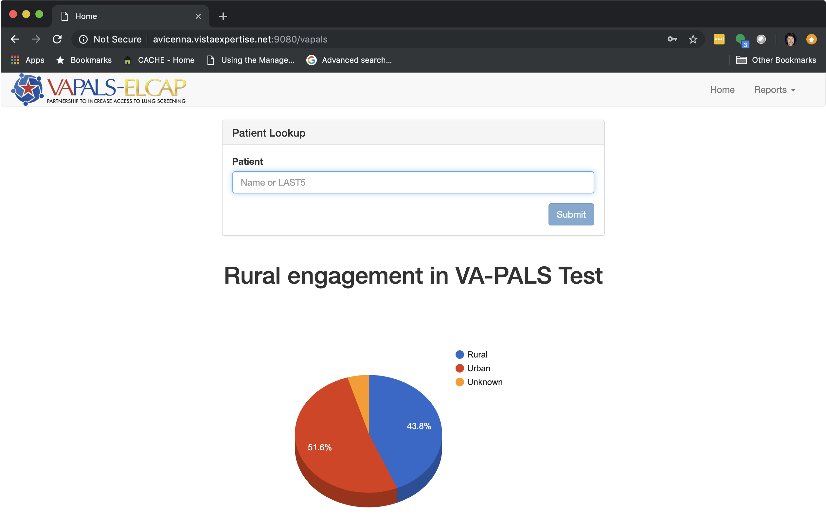

A new patient can be selected from the Home Page. Basic patient demographics are pulled each night from the VAMC’s Vista database and used to populate the drop down for patient selection. If a patient is not already in the system from the nightly pull or existing in the database there is no way to add them directly to the VAPALS database. This is to make sure the patient is already enrolled in the system and to prevent accidental duplications.

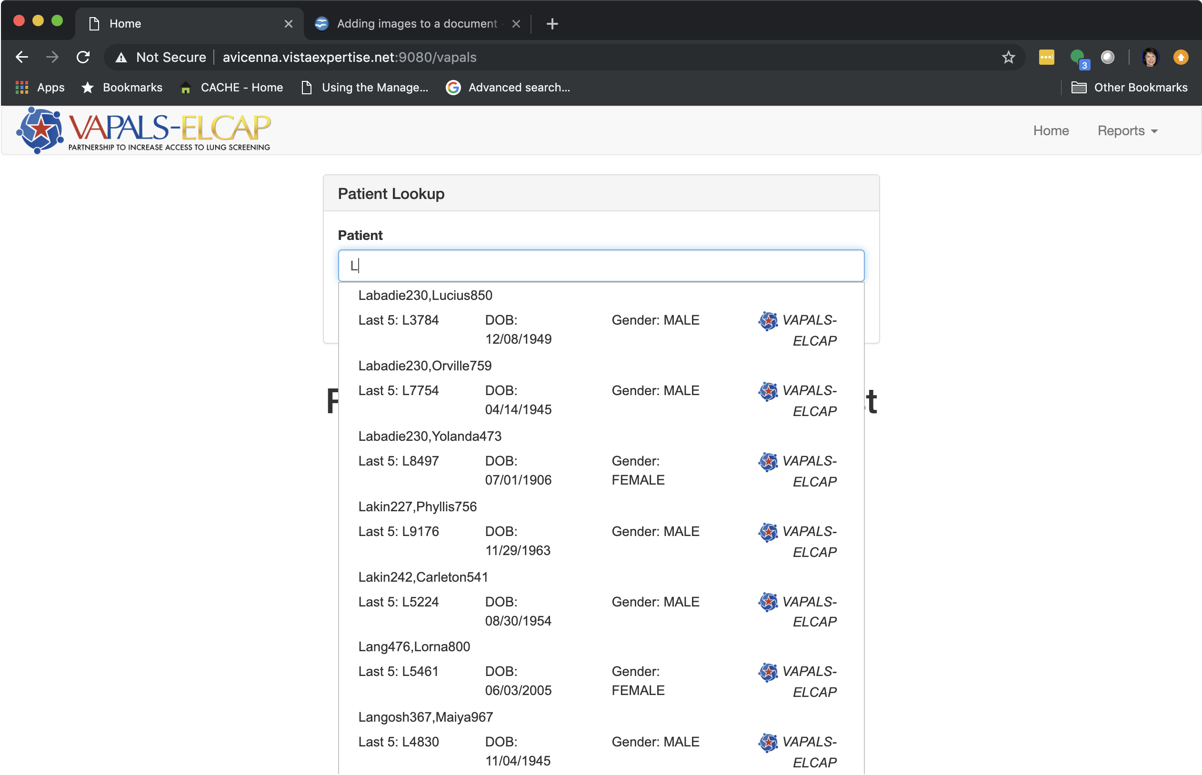

If a new patient is enrolled, a new intake form is opened for the patient.

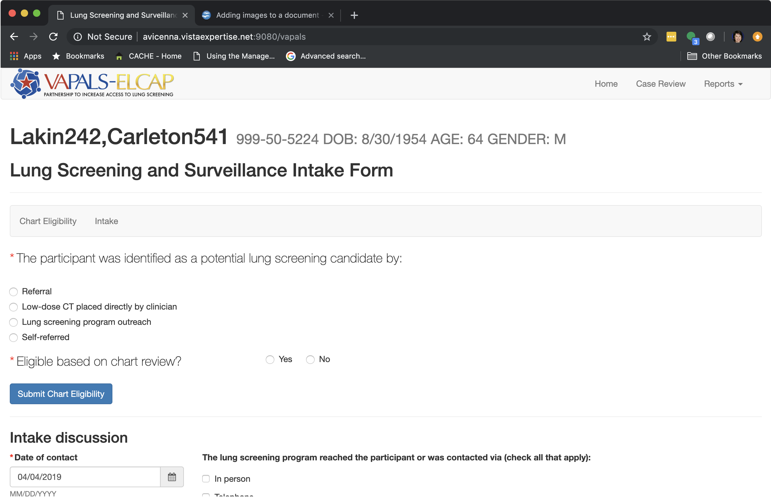

If an existing patient is selected, the Case Review Page is opened for that patient.

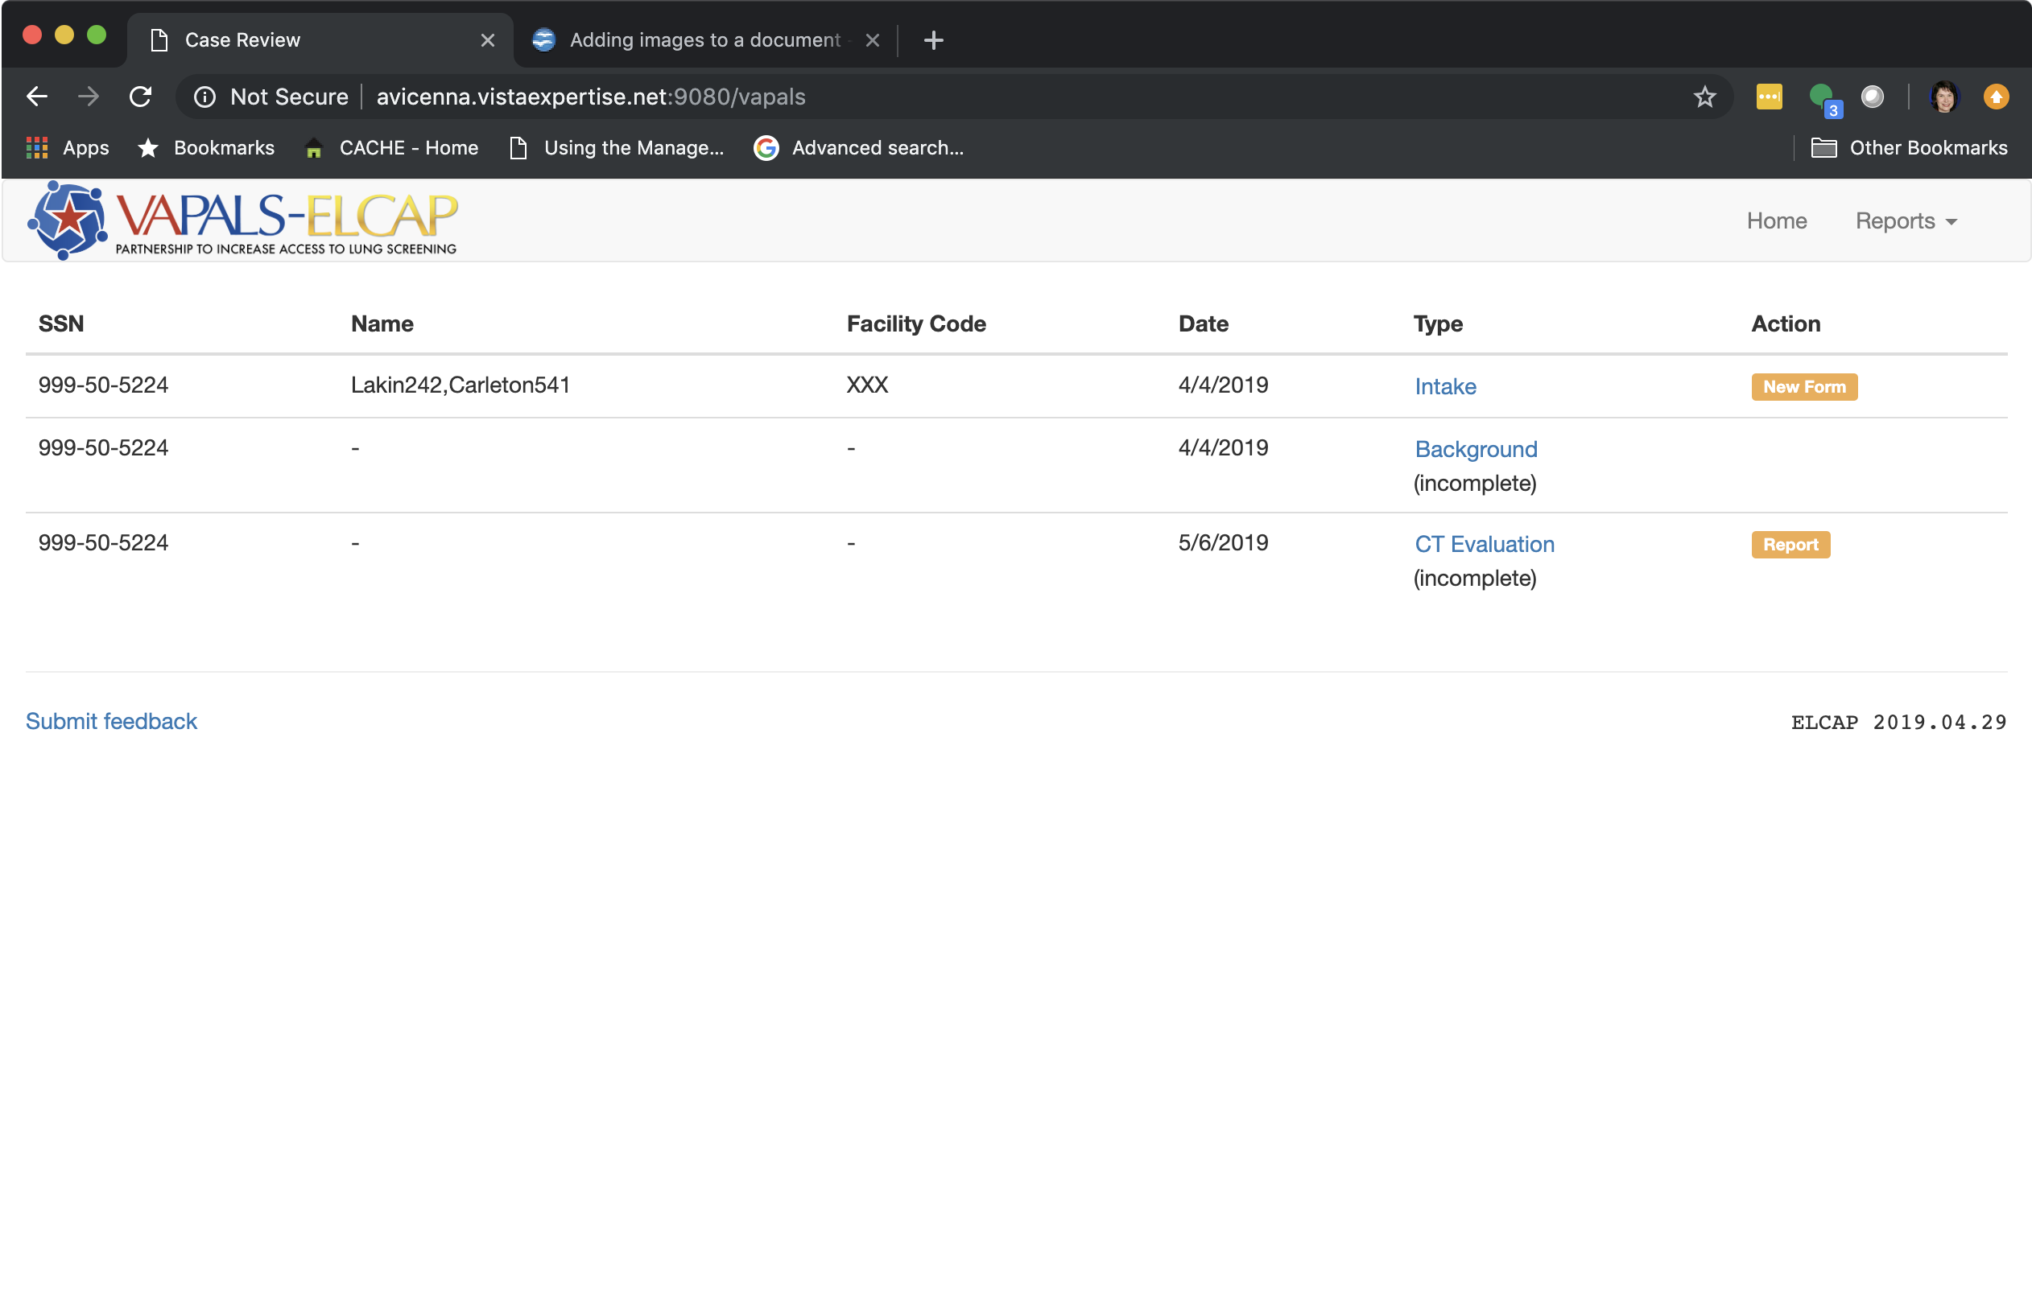

When the user wants to run a user report, they select Report at the top of any page and choose the report they want in the dropdown.

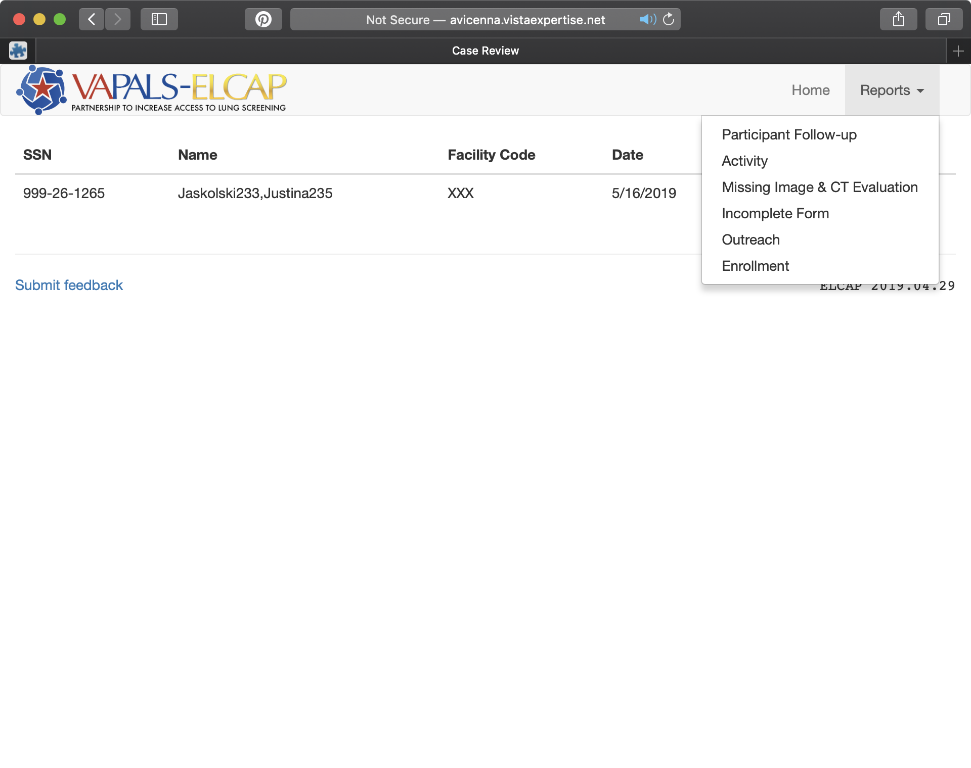

These screens are examples of how the user interacts with VAPALS-ELCAP. For a more complete write-up of the user interface, please see the User Manual included with this submission.

# Executed Unit Tests

Unit tests were developed for all of the routines created in the SAMI namespace for VAPALS-ELCAP except, of course, for unit test routines. To run all of the unit tests, DO ^SAMIUT. To run a coverage report DO COVERAGE^SAMIUT. Verbosity for the coverage routine is hard set to “2” in the SAMIUT routine. Coverage is usually around 92%.

# Code Walkthrough

## Fileman Files

Most data is stored in graphs, please see the next section for a list of those.

|  |  |
| --- | --- |
| **File** | **Description** |
| File SAMI Form Mapping (#311.11) | This is a form mapping file created by gpl for the VAPALS project It maps the variable names used in the ELCAP forms to field numbers in fileman files. |

## Graphs

A list of the graphs used for storing data for the VAPALS-ELCAP with a brief description of each are in the below table.

| **Graph Name** | **Description** |
| --- | --- |
| form fields - background | Data Dictionary for background form |
| form fields - biopsy | Data Dictionary for the biopsy form |
| form fields – ct evaluation | Data Dictionary for the ct evaluation form |
| form fields – follow-up | Data Dictionary for the follow-up form |
| form fields - intake | Data Dictionary for the intake form |
| form fields - intervention | Data Dictionary for the intervention form |
| form fields – pet evaluation | Data Dictionary for the pet evaluation form |
| html-cache | Copies of the HTML files cached for rapid access by the VAPALS-ELCAP form processor |
| NCHS Urban-Rural | Urban-Rural database by zip code |
| patient-lookup | Patient demographics pulled from VA server |
| seeGraph | The location of each of the HTML files used by VAPALS-ELCAP |
| vapals unit tests | Data used by VAPALS-ELCAP unit tests |
| vapals-patients | Patients registered in VAPALS |

## Routine Breakdown

A list of routines with a brief description of each are in the appendix.

## Web Templates

VAPALS-ELCAP uses web templates written in HTML to format the forms so they can be used with web browsers. These templates are in the docs/www folder in the Docker instance and in the OSEHRA repository.

# Conclusion

The VAPALS-ELCAP software package is designed to complement I-ELCAP protocols and make administering and analyzing an early lung screening program in an efficient and user-friendly manner. It’s exciting to know that we’ll be saving some lives as this program becomes available at the VAMCs.

# Appendix

## Mumps Routines

SAMIADMN—Administration tools

SAMICAS2—SAMICASE and SAMICAS2 and 3 creates the Case Review Page

SAMICAS3

SAMICASE

SAMICLOG—Builds the change log in the Intake Form

SAMICTC1—This and the next routine selectively copy the CT Eval Form

SAMICTC2

SAMICTD2—English translation dictionary from fields to CT Eval Report

SAMICTR—debugging version of SAMICTR0

SAMICTR0—Web service returns an html CT Eval Report

SAMICTR1—SAMICTR1-4, SAMICTR9, SAMICTRA support SAMICTR0

SAMICTR2

SAMICTR3

SAMICTR4

SAMICTR9

SAMICTRA

SAMICTRX—Matches variables to dictionary or patient data

SAMICUL—Log for SAMICAS* routines

SAMIFDM—SAMIFORM direct mode interfaces

SAMIFF—Build a graph of form fields

SAMIFLD—Load JSON data into the graphstore

SAMIFORM—Form library

SAMIFUL—Log for SAMIF* Routines

SAMIFWS—Web services debugging routines-not used in production

SAMIHOM3—This routine and SAMIHOM4 are the opening ones for the application. They create the Home Page, provide some of the web servers, register the patient in the program, and start tocreate the Intake Form.

SAMIHOM4—See SAMIHOM3

SAMILOG—Turns authentication on and off

SAMIM2M—Provide standardized entrance into M2M broker

SAMINOT1—Handles intake note creation and organization

SAMINOTI

SAMIPTLK—Look up Patient Data in the patient-lookup cache

SAMIRU—Determines veteran’s rural or urban status

SAMISAV—Extrinsic which returns the form key for saving

SAMISRC2—Provides patient search capability on home page

SAMIUL—License text for application

SAMIUR—Generates user reports with support of SAMIUR1 and 2

SAMIUR1

SAMIUR2

SAMIUT*—Unit test suite

SAMIVST1—This and the next five routines support SAMIVSTA

SAMIVST2

SAMIVST3

SAMIVST4

SAMIVST5

SAMIVSTA—Handle interactions with Vista (example: TIU notes, patient data pulls)

SAMIVUL—Log for SAMIVST* module

## Unit Test Suite

|  |  |
| --- | --- |
| **Test Routine** | **Routine That is Tested** |
| SAMIUT | Master unit test |
| SAMIUTAD | SAMIADMN |
| SAMIUTC1 | SAMICTC1 |
| SAMIUTC2 | SAMISRC2 |
| SAMIUTCG | SAMICLOG |
| SAMIUTCR | SAMICTR |
| SAMIUTD2 | SAMICTD2 |
| SAMIUTF | SAMIFORM, SAMIFDM, SAMIFLD, SAMIFWS |
| SAMIUTFF | SAMIFF |
| SAMIUTH3 | SAMIHOM3, SAMIHOM4 |
| SAMIUTH4 | SAMIHOM3, SAMIHOM4 |
| SAMIUTLG | SAMILOG |
| SAMIUTM2 | SAMIM2M |
| SAMIUTN1 | SAMINOT1 |
| SAMIUTNI | SAMINOTI |
| SAMIUTPT | SAMIPTLK |
| SAMIUTR0 | SAMICTR0 |
| SAMIUTR1 | SAMICTR1 |
| SAMIUTR2 | SAMICTR2 |
| SAMIUTR3 | SAMICTR3 |
| SAMIUTR4 | SAMICTR4 |
| SAMIUTR9 | SAMICTR9 |
| SAMIUTRA | SAMICTRA |
| SAMIUTRU | SAMIRU |
| SAMIUTRX | SAMICTRX |
| SAMIUTS2 | SAMICASE, SAMICAS2, SAMICAS3 |
| SAMIUTST | Routine to push and pull information used during unit testing of va-pals routines |
| SAMIUTSV | SAMISAV |
| SAMIUTUR | SAMIUR, SAMIUR2 |
| SAMIUTVA | SAMIVSTA |
| SAMIUTVB | SAMIVSTA |
| SAMIUTVR | SAMIVSTA |
| SAMIUTVS | SAMIVSTA |